PSD

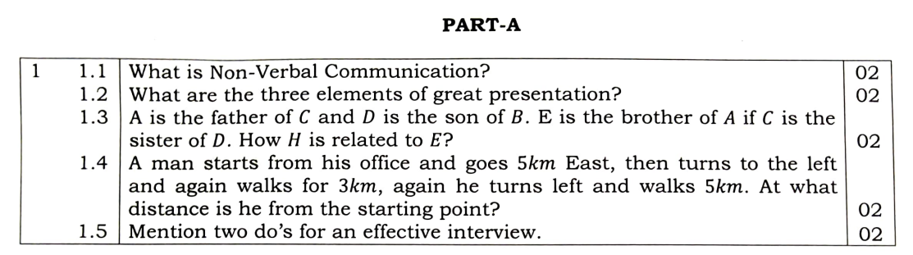
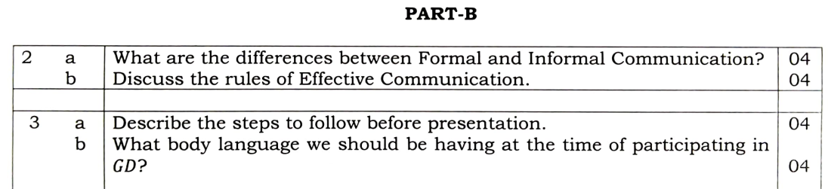
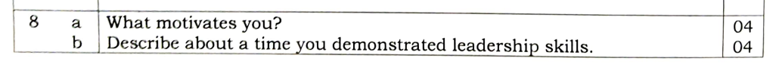

Communication – Verbal and Non Verbal

Formal vs Informal

Rules for Effective Communication

3 Elements of Presentation

Steps to follow before Presentation

GD – Phases, DO and DONT

Gestures – Examples

Resume vs Biodata

COMMUNICATION

Sharing of Information (FIOT - Feelings, Ideas, Opinions, Thoughts) in the form of:
(Verbal) Speaking, Reading, Writing
(Non Verbal) Expressions, Body Language
Every communication involves:

- Sender
- Message
- Recipient
1) Verbal Communication

The communication which is in the form of:

Reading, Writing, Speaking

Message is transmitted through WORDS

Words are given to Feelings, Ideas, Opinions, Thoughts (FIOT)

EXAMPLE: Conversation, Speeches, Discussion, Letter

2) Non Verbal Communication

The communication in the form of: Expressions, Body Language

Conveying message without the use of words.

EXAMPLE: Communication using Facial Expressions, Body Language,

Hand Movements, Postures, Gestures

FORMAL Communication vs INFORMAL Communication

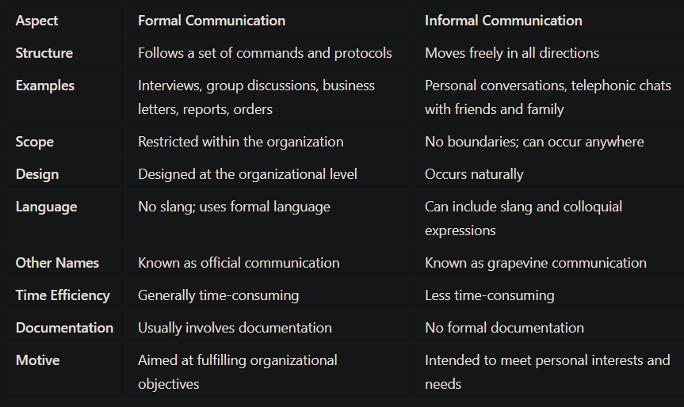

RULES for EFFECTIVE COMMUNICATION [ACC LP] [TVS]

1. Audibility

2. Clarity

3. Confidence

4. Listening skills

5. Presentation skills

6. Talk with people, not at people.

7. Proper Matching of Verbal and Non Verbal

8. Proper construction of Sentences

Three Elements of Great Presentation [VCD]

VISUALS

Enhance understanding and retention.

Includes: Slides, Charts, Videos, Props to support your message.

CONTENT

Foundation of your presentation.

It should be: Clear, Relevant, Engaging, Well-structured, Logical

Use: Data, Stories, Examples to support your message.
DELIVERY

How you present your content is just as important

Includes: Body language, vocal tone, pacing, eye contact.

STEPS to Follow before Presentation [UP RIP PQT]

Understand: Clarify the topic focus

Plan: Identify subtopics

Research: Gather relevant information on the assigned topics

Implement: Create slides that highlight key points
Additional Features: Enhance slides with images, graphs, animations

Preparation: Prepare to explain points, not just reading slides

Presentation: Speak confidently, eye contact, gestures.

Dress formally and keep language concise.

Query Handling:

- Encourage audience questions

- Respond calmly and politely

Thank the Audience: Collect your materials and exit graciously

GROUP DISCUSSION

GD is a collaborative discussion involving multiple participants on a specific topic, aimed at reaching a consensus.

It is "many on many" discussion

Is is distinct from a debate ("one on one")

Phases of GD

1) Initiation Phase:

One panel member starts the discussion.

a) Greeting Participants

b) Self-introduction

c) Introducing of Topic

d) Overview: Definitions, Quotations, Facts, Stories, Questions

e) Present their Viewpoint on the topic

2) Body of Discussion:

The core discussion occurs here.

Participants exchange opinions.

Members introduce themselves and present their viewpoints.

3) Conclusion Phase:

A summary of the discussion is presented by one member.

Highlighting key points discussed.

DO’s

Dress Formally Eye Contact Allow Participation

Stay Calm Speak Relevant Listen Actively

DONT’s

Casual Attire Ignoring Others Dominating Others
Aggression Avoid Irrelevance Don’t Interrupt

Body Language in GD

Upright Posture Eye Contact Nodding

Smile Gestures Calm and Confident

GESTURES

Gestures refers to

- Physical Movements of the body

- Particularly the hands and arms

It is used to express (FIEI) feelings, ideas, emotions, intentions.

They enhance verbal communication

Provides emphasis, clarifying meaning, conveying feelings.
Examples:
Thumbs Up: This gesture typically signifies approval or agreement. It can convey encouragement, satisfaction in a conversation.
Pointing: Using a finger to point at something can draw attention to a specific object or idea, helping to clarify a message during discussions or presentations.
Open Hands: Holding your hands open and facing upward can indicate honesty, openness, and willingness to engage in dialogue, creating a welcoming atmosphere during communication.

RESUME vs BIODATA

